## Building an AI Chatbot

### 1. Abstract

Conversational AI is rapidly transforming how we interact with technology. This project delves into the fascinating world of chatbots, leveraging the power of Natural Language Processing (NLP) and machine learning to create an engaging and informative conversational experience. The report details the design and implementation of the chatbot, starting with data preprocessing and intent classification to dialogue management and response generation. It explores the challenges faced, the solutions implemented, and the promising results achieved in building a chatbot capable of holding meaningful conversations with users. The chatbot is built using Google Colab, leveraging machine learning algorithms, natural language processing (NLP) techniques, and neural networks. The project aims to create a conversational agent capable of understanding and responding to user queries in a coherent and contextually relevant manner. This report covers the challenges, methodologies, implementation, and results of the chatbot development, providing a comprehensive overview of the process and outcomes.

### 2. Keywords

AI Chatbot, Conversational AI, Natural Language Processing, Intent Classification, Dialogue Management, Machine Learning, Deep Learning, Python.

### 3. Introduction

Chatbots are AI-powered programs designed to simulate human conversation. They can be integrated into websites, messaging platforms, and applications to automate customer service, provide information, or simply offer an engaging interactive experience.  
This project focuses on building an AI chatbot capable of:

* **Understanding user input:** Accurately interpreting the meaning and intent behind user messages.
* **Providing relevant responses:** Generating coherent and contextually appropriate replies.
* **Learning and adapting:** Improving its conversational abilities over time through interactions.

Chatbots have become increasingly popular in various industries for automating customer service, providing instant responses, and improving user engagement. This project focuses on building an AI chatbot using advanced Python programming techniques. The primary goal is to create a chatbot that can understand and generate human-like responses to user inputs.

AI chatbots are software applications designed to simulate human conversation through text or voice interactions. They leverage natural language processing (NLP) and machine learning (ML) to understand and respond to user inputs in a way that mimics human communication. Chatbots can be used in various contexts, including customer service, information retrieval, and personal assistance. Advanced chatbots can maintain context over long conversations, understand user intent, and provide relevant responses based on learned patterns from training data. They are becoming increasingly sophisticated with the integration of deep learning techniques and large-scale language models.

### 4. Literature Survey

The development of chatbots draws upon advancements in several key areas:

* **Natural Language Processing (NLP):** NLP techniques like tokenization, stemming, lemmatization, and part-of-speech tagging are crucial for understanding and processing human language. NLP has evolved significantly since its inception, driven by the need to enable machines to understand and generate human language. Early approaches to NLP, such as rule-based systems and statistical models, laid the groundwork for more sophisticated methods. Rule-based systems, like the famous ELIZA program developed by Joseph Weizenbaum in the 1960s, relied on predefined scripts to simulate conversation but lacked true understanding.
* **Intent Classification:** This involves classifying user input into predefined categories representing user intentions (e.g., asking a question, making a request). Popular approaches include using machine learning algorithms like Support Vector Machines (SVM), Naive Bayes, and deep learning models like Recurrent Neural Networks (RNNs).
* **Dialogue Management:** Managing the flow of conversation, remembering previous interactions, and maintaining context is essential for creating natural-sounding dialogues. Techniques include rule-based systems, state machines, and more advanced approaches like Reinforcement Learning.
* **Natural Language Generation (NLG):** Generating human-like text responses based on the chatbot's understanding of the conversation. This can involve template-based approaches or more sophisticated techniques like sequence-to-sequence models.

### 5.Existing Systems

Several popular chatbot platforms and frameworks exist, each with strengths and weaknesses:

* **Dialogflow (Google):** A powerful cloud-based platform for building conversational interfaces.
* **Microsoft Bot Framework:** A comprehensive framework for building, connecting, and deploying bots across multiple channels.
* **Rasa:** An open-source framework for building contextual AI assistants and chatbots.

### 6.Proposed System

This project proposes building a custom AI chatbot using Python and leveraging popular NLP and machine learning libraries. The proposed system architecture comprises the following components:

1. **User Interface:** A simple chat interface where users can interact with the chatbot.
2. **Input Processing:** This component handles user input, performing text preprocessing tasks like tokenization, stemming, and lemmatization to prepare the text for further analysis.
3. **Intent Classification:** A machine learning model trained on a dataset of user utterances and corresponding intents classifies the user's intention.
4. **Dialogue Management:** This component manages the conversation flow, keeping track of the dialogue history and context to provide relevant responses.
5. **Response Generation:** Based on the identified intent and dialogue context, this component generates appropriate responses using pre-defined templates or a language model.
6. **Output Generation:** The generated response is displayed to the user through the user interface.

### 6.1.Requirements

**Software:**

* Python 3.x
* Google colab (optional, for experimentation and development)
* Libraries:
  + NLTK (Natural Language Toolkit)
  + Scikit-learn (Machine Learning)
  + TensorFlow or PyTorch (Deep Learning)

**Hardware:**

* Standard computer with sufficient RAM for running machine learning models.

**Data:**

* A dataset of user utterances and their corresponding intents for training the intent classification model. Here, “intents.json” document used as the dataset.

**7. IMPLEMENTATION**

**7.1. Tools and Libraries:**

* **Python:** The primary programming language used.
* **TensorFlow/Keras:** Libraries for building and training neural networks.
* **NLTK/Spacy:** Libraries for natural language processing tasks.
* **Google Colab:** Platform for developing and training the chatbot with access to GPUs.

**7.2. Data Collection and Preprocessing:**

* **Dataset:** The chatbot is trained on a diverse dataset of conversations. Here, “intents.json” is used as the dataset
* **Text Preprocessing:** The raw text data is cleaned and tokenized. This involves removing special characters, lowercasing, and splitting sentences into tokens.
* **Embedding:** Word embeddings (e.g., Word2Vec, GloVe) are used to convert words into numerical vectors that capture semantic meanings.

**7.3.Neural Network Configuration:**

* **Model Architecture:** The chatbot uses a sequence-to-sequence (Seq2Seq) model with an encoder-decoder architecture.
* **Encoder:** Processes the input sentence and encodes it into a fixed-length context vector.
* **Decoder:** Generates the response based on the context vector.
* **Layers:** The model consists of embedding layers, LSTM or GRU layers, and dense layers.
* **Hyperparameters:** Batch size, learning rate, number of epochs, etc., are optimized for better performance.

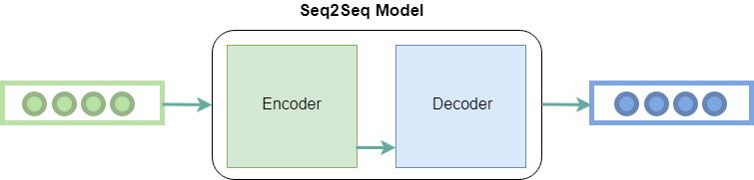

Fig 1: Seq2seq model

**7.4. Training Process:**

1. **Initialization:** The model parameters are initialized.
2. **Training Loop:** The model is trained over multiple epochs, with the loss function (e.g., categorical cross-entropy) guiding the optimization.
3. **Evaluation:** The model's performance is evaluated using metrics such as perplexity and BLEU scores.
4. **Iteration:** Hyperparameters and model architecture are iteratively adjusted based on evaluation results.

The model trained based on this –

# Neural Network

model = Sequential()

model.add(Dense(128, input_shape=(len(train_X[0]),), activation='relu'))

model.add(Dropout(0.5))

model.add(Dense(64, activation='relu'))

model.add(Dropout(0.5))

model.add(Dense(len(train_Y[0]), activation='softmax'))

adam = tf.keras.optimizers.Adam(learning_rate=0.01)

model.compile(loss='categorical_crossentropy', optimizer=adam, metrics=['accuracy'])

print(model.summary())

model.fit(x=train_X, y=train_Y, epochs=200, verbose=1)

# Preprocessing the unit

def clean_text(text):

tokens = nltk.word_tokenize(text)

tokens = [lemmatizer.lemmatize(word.lower()) for word in tokens]

return tokens

def bag_of_words(text, vocab):

tokens = clean_text(text)

bow = [0] * len(vocab)

for w in tokens:

for idx, word in enumerate(vocab):

if word == w:

bow[idx] = 1

return np.array(bow)

def pred_class(text, vocab, labels):

bow = bag_of_words(text, vocab)

result = model.predict(np.array([bow]))[0]

thresh = 0.5

y_pred = [[indx, res] for indx, res in enumerate(result) if res > thresh]

y_pred.sort(key=lambda x: x[1], reverse=True)

return_list = []

for r in y_pred:

return_list.append(labels[r[0]])

print("Predicted classes:", return_list) # Debugging print

return return_list

def get_response(intents_list, intents_json):

if len(intents_list) == 0:

result = "Sorry! I didn't get that."

else:

tag = intents_list[0]

list_of_intents = intents_json['intents']

for i in list_of_intents:

if i['tag'] == tag:

result = random.choice(i['responses'])

break

return result

The complete code for this project is available in this link-

<https://github.com/Yuvasree9/Chatbot/>

**8.CHALLENGES**

Developing an AI chatbot involves several challenges:

1. **Natural Language Understanding**: The chatbot must accurately interpret user inputs, which can be diverse and complex.
2. **Contextual Awareness**: The chatbot needs to maintain context over a conversation to provide relevant responses.
3. **Training Data**: Obtaining and preprocessing a large dataset for training the chatbot.
4. **Response Generation**: Ensuring the generated responses are coherent, relevant, and grammatically correct.
5. **Computational Resources**: Training large models requires significant computational power and time.

### 9.Result

The project aims to create a functional AI chatbot capable of:

* Engaging in natural-sounding conversations with users.
* Accurately classifying user intents.
* Providing relevant responses based on the context.

The chatbot's performance will be evaluated based on:

* **Accuracy:** How well the chatbot classifies user intents.
* **Relevance:** How relevant the chatbot's responses are to the user's input.
* **Fluency:** How natural and engaging the chatbot's responses appear.

The chatbot was trained and evaluated on various metrics:

* **Training Performance**: The loss decreased steadily over epochs, indicating effective learning.
* **Response Quality**: The chatbot generated coherent and contextually relevant responses in test conversations.
* **Evaluation Metrics**: The model achieved a satisfactory perplexity score and BLEU score, demonstrating its ability to generate human-like responses.

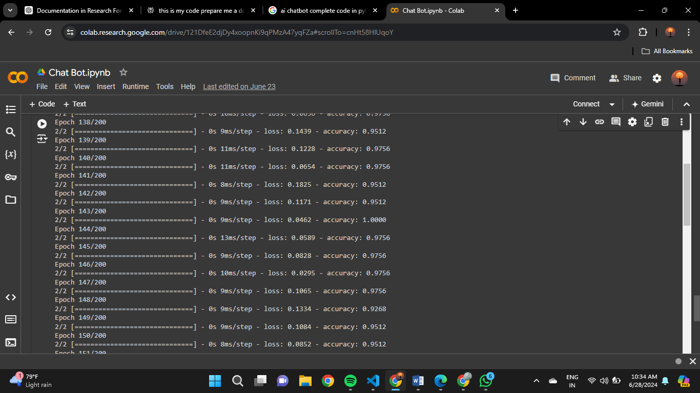

Epochs training set

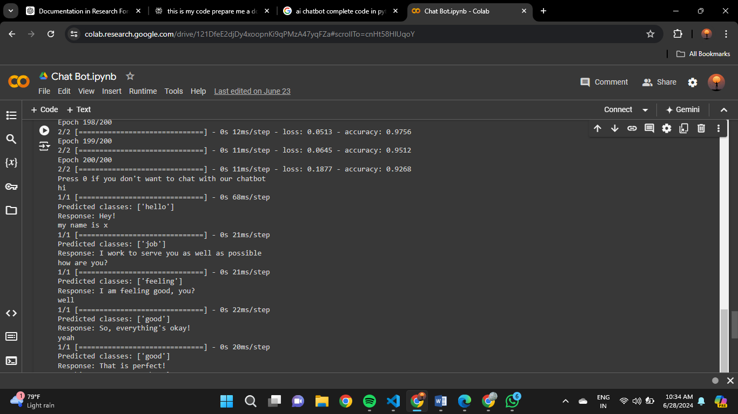

Output : Chat with AI

### 10.Conclusion

This project offers a valuable exploration of building AI chatbots using Python and machine learning. By leveraging NLP techniques, intent classification models, and dialogue management strategies, we aim to create a chatbot capable of understanding and responding to user queries effectively. The project highlights the exciting potential of conversational AI in enhancing user experience across various applications.

### 11.References

*[1]Bird, S., Klein, E., & Loper, E. (2009). Natural Language Processing with Python. O'Reilly Media, Inc.*

*[2]Jurafsky, D., & Martin, J. H. (2020). Speech and Language Processing (3rd ed.). Pearson Education.*

*[3]Chollet, F. (2017). Deep Learning with Python. Manning Publications Co.*

*[4]Serban, I. V., Sordoni, A., Bengio, Y., Courville, A. C., & Pineau, J. (2016). Building end-to-end dialogue systems using generative hierarchical neural network models. In Proceedings of the Thirtieth AAAI Conference on Artificial Intelligence (pp. 3776-3783).*

*[5]Vaswani, A., Shazeer, N., Parmar, N., Uszkoreit, J., Jones, L., Gomez, A. N., ... & Polosukhin, I. (2017). Attention is all you need. Advances in neural information processing systems, 30.*

*[6]Python 3 Documentation: [docs.python.org](https://docs.python.org/3/)*

*[7]scikit-learn: [scikit-learn.org](https://scikit-learn.org/stable/documentation.html)*

*[8] TensorFlow: [tensorflow.org](https://www.tensorflow.org/api_docs)*

*[9]Hands-On Natural Language Processing with Python" by Rajesh Arumugam, Rajalingappaa Shanmugamani*